**Can Mathematical Networks Tell Us How to Play Minecraft Optimally?**

**By: Josh Limon**



**Math and Minecraft**

If you’ve played a video game before, I would guess that you’ve probably played Minecraft before. Why do I say that? Well according to Wikipedia and this article by the Verge [1], Minecraft is the best selling game to have ever existed. I personally am a huge fan of Minecraft. I have bought three copies (for friends of course, why would I need more than one account now that we can change usernames?) and have been playing for ten years now. I particularly enjoy using hundreds of mods (user-created changes and additions to the game) while I play, especially modpacks like Tekkit, Feed the Beast, and Enigmatica 2.

I’m a math major at UCLA and so I was recently thinking to myself, “Man, all this abstract math is cool and all but, until I get a job, how is this math and science I’ve learned useful?!”, as I’ve learned a lot of non-math majors also wonder. While mining in Minecraft (probably the most boring part of the game), the idea came to me! Let’s try and see if I can speed up mining to get those precious diamonds faster!

**Networks and Math**

Before I can tell you how I used the power of math to achieve that goal, I first must tell you a bit about network theory and my taste in movies. Network theory is the study of networks (duh). A **network** is a large collection of data, people, objects, Amazon items, etc. each of which is called a “**node**”. These nodes are connected in some way via lines called “**edges**”. If two nodes are connected by an edge, then these nodes are related in some way that you get to decide.. If two nodes are not connected then they are not related. For example, if you had a list of all the items on Amazon and a list of all the users (that would be a really large number of nodes), and we wanted to create a network of ratings, we could connect an item to a user by an edge if the user had rated the item. What if we wanted to assign to each edge the rating that the user gave the item? Then this would be called a **weighted network**. Check out an example of a tiny network of my friends and I rating movies below.



Fig 1: A weighted, bipartite network of me and my friends rating movies! I have the best taste, of course. From top to bottom, our names are Josh, Dalton, and Joe!

From this graph you can see what my friends look like, what movies we’re rating and what we rate each movie, right? In network theory terms the ratings are edges, the amount of stars is the weight, and both the movies and people are nodes. Also, we’ll come back to this later but a **random walk** on a network is a path given by going down a random edge at a node. For example, if we wanted to do a random walk of length two starting at me (Josh), we would go to Shrek the Third (the only edge connected to me), and then we would go down one of the three edges from there at random, either back to me or to Dalton or Joe.

**Networks and Minecraft and Math, Oh My!**

Alright, enough learning terms and their meanings, you’ll have more time for that in your own research and internet browsing. How does all this network theory help you get those precious, blue, shiny rocks in Minecraft faster? Well let’s start with the basics of mining efficiently in Minecraft. When you start mining in Minecraft for diamonds, don’t you think it would be best to mine for diamonds in the place that has the most diamonds? I sure do.

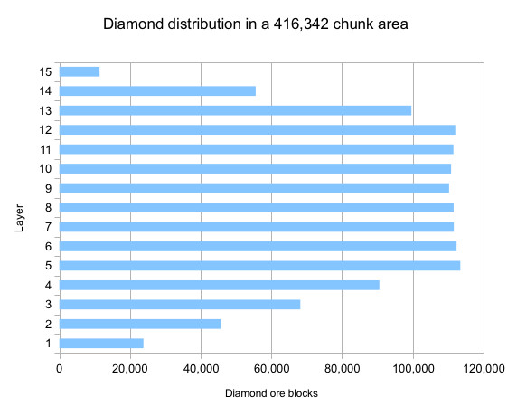

Fig 2. A public domain chart of how many diamond ore are at different y-levels in Minecraft [2].

In Minecraft, the cube blocks that make up the world are arranged according to three-coordinates, the x and z-coordinates which make up the horizontal or flat directions and the y-coordinate which is the up-and-down or vertical direction. From the chart above, it seems best to mine at any y-level from y=5 to y=12. However, a quick glance at the official Minecraft wiki page for the dangerous lava block reveals that lava generates at layers y=1 to y=10 [2]. It’s therefore best to mine at y=12 (you might think y=11, however, if you’re trying to mine as fast as possible, you risk falling into a lava block at y=10 where it can generate at your feet when you uncover a new block). Okay cool, so you might think we’re done, as I did for ten years. You just mine in one direction with an efficiency V diamond/netherite pickaxe and shovel (some of the fastest tools for mining) and you’’ find diamonds as fast as possible, right?

**Investigating a Special Block, and How to See it’s Special**

When I was mining during my quarter in network theory, I noticed that I could mine dirt faster than I could mine stone, and after checking the Minecraft wiki it revealed that I could mine dirt three times as fast as stone [3]! So I sought out to see if I would find diamonds more often if I would mine all out all the dirt (or any other block, gravel is similar) in a patch anytime I found it. The method for figuring this out is simple, figure out how many blocks you reveal each time you break a block and multiply that by the amount of blocks you can break in a second for any block. Do this for each block and multiply that by the amount of times a block appears next to a diamond ore divided by the amount of diamond ores you checked multiplied by six (since a cube has six faces or sides, each diamond ore neighbors six blocks).

At this point, you might have caught on that this can be modelled as a network with the blocks as nodes that are connected by an edge if they’re connected in game (including air/empty blocks). For the sake of this problem, using a weighted network with the time it takes to break the block further from the player is also helpful because we can then model mining as a random walk starting at the block the player is starting at! One unrealistic assumption that this makes is that the player can instantly react and mine the correct block, but this can be ignored since, if we’re trying to mine as fast as possible, the player would already have been assumed to do this anyway.

If you’re paying attention, you’d notice there’s only one thing missing, and that’s that number we discussed earlier. Specifically, we’re missing the number for the amount of times a block appears next to a diamond ore divided by the amount of diamonds ores we checked. To figure these numbers out, I coded a plugin for the third party Minecraft save editor tool, MCEdit, developed by @codewarrior0 [4]. I’ll include a link to my plugin and code for organizing the data at the end [5]. You can see the results of my coding below after checking 10 unique v1.10 worlds (in total there were 141,774 blocks investigated, or 23,624 diamond ore):

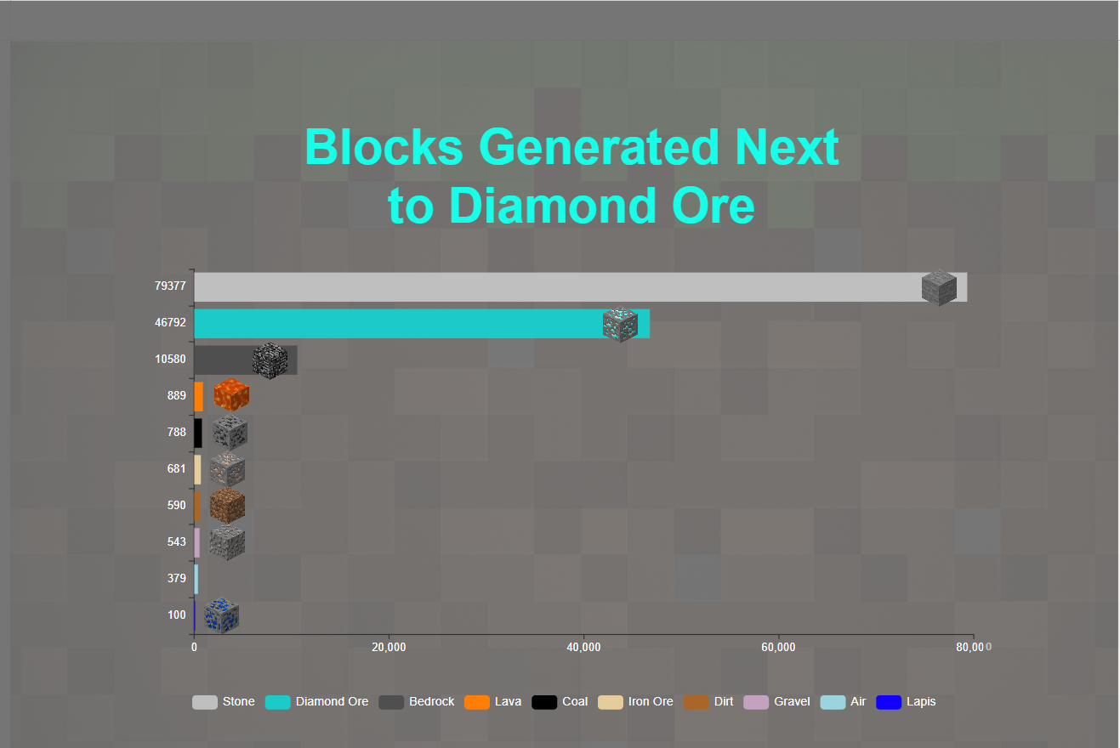

Fig 3: Frequency of times block type spawned next to Diamond Ore out of 23,624 diamond ore checked.

**The Results**

The results sure are probably surprising to most! The blocks most often generated next to diamond ore are other diamond ore (not surprising since they spawn in veins) and stone, the next most commonly generated blocks, bedrock and lava, are unbreakable so we shouldn’t even count them. Any other block, since it occurs less than 1,000 times in 140,000 blocks checked, would have to be 140x faster to break than stone! No such block exists, so while we thought it would be faster to maybe mine dirt or any other block besides stone, we learned the opposite, you should probably only be mining stone to find veins of diamond ore! In other words, if you’d like, every time you encounter gravel, dirt, or any other slow block that’s unlikely to have diamonds next to it, it might be worth it to mine to the right or left instead.

Alright Mr. Math, so we did all this work just for you to tell us that no such special blocks exist except for the most likely common underground block, stone? That’s right! That’s perfectly fine, in science and math, the goal is to investigate the truth, not to make sure we’re not wasting our time trying an experiment that will tell us the old way is correct. Network theory is used to solve a variety of other problems, such as modelling Russian Trade Networks from the 1600s, or modelling the spread of the COVID-19 disease, leading to the result that we should optimally give the vaccine to people who are more likely to spread it than to give it to high-risk individuals. Be sure to never stop questioning!

**Glossary**

**Network:** A data set of nodes and edges.

**Nodes:** A thing represented in a network that gets connected to other things if a given relationship exists between them.

**Edges**: A connection between two nodes that represents a given relationship. In our article, an edge represents two blocks being next to each other

**Weighted Network:** A network where the edges also have a number, or weight, associated with them

**Random Walk:** A randomly generated path where you start at a given node, and go down each possible edge connected to that node with equal probability.

**References**

[1] Warren, Tom. The Verge. *Minecraft sales top 100 million*. <https://www.theverge.com/2016/6/2/11838036/minecraft-sales-100-million>. Web. Jun 2, 2016. Accessed Dec. 18, 2020.

[2] “Diamond Ore”. Official Minecraft Wiki. Web. Dec. 18, 2020 <https://minecraft.gamepedia.com/Diamond_Ore> (by User Orthotope).

[3] “Breaking”. Official Minecraft Wiki. Web. Dec. 18, 2020 https://minecraft.gamepedia.com/Breaking

[4] <http://www.mcedit.net/>

[5] (Not technically a Reference but my code):https://github.com/exojosh/MCEdit-Plugins